How to Create an SRG/STIG ID Mapping Spreadsheet

- Import the SRG/STIG XML into the latest version of STIG Viewer.
- Select the SRG/STIG by clicking on it.
- Click Export >> Spreadsheet (.csv).
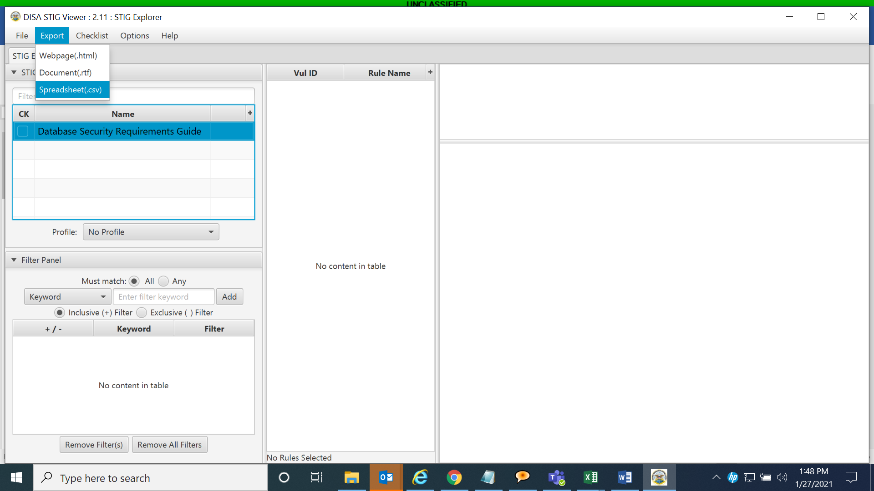
  - Note: Remove columns by selecting them in the right column and clicking on the arrow pointing left.
- Once all desired rows are remaining in the right column, click OK.
  - Note: Ensure the following are selected: STIG ID, Legacy (contains both V and SV keys from old version of DPMS), Vuln ID, and Rule ID.
